Colour in the picture below and fill in the blank spaces, then answer the questions below.

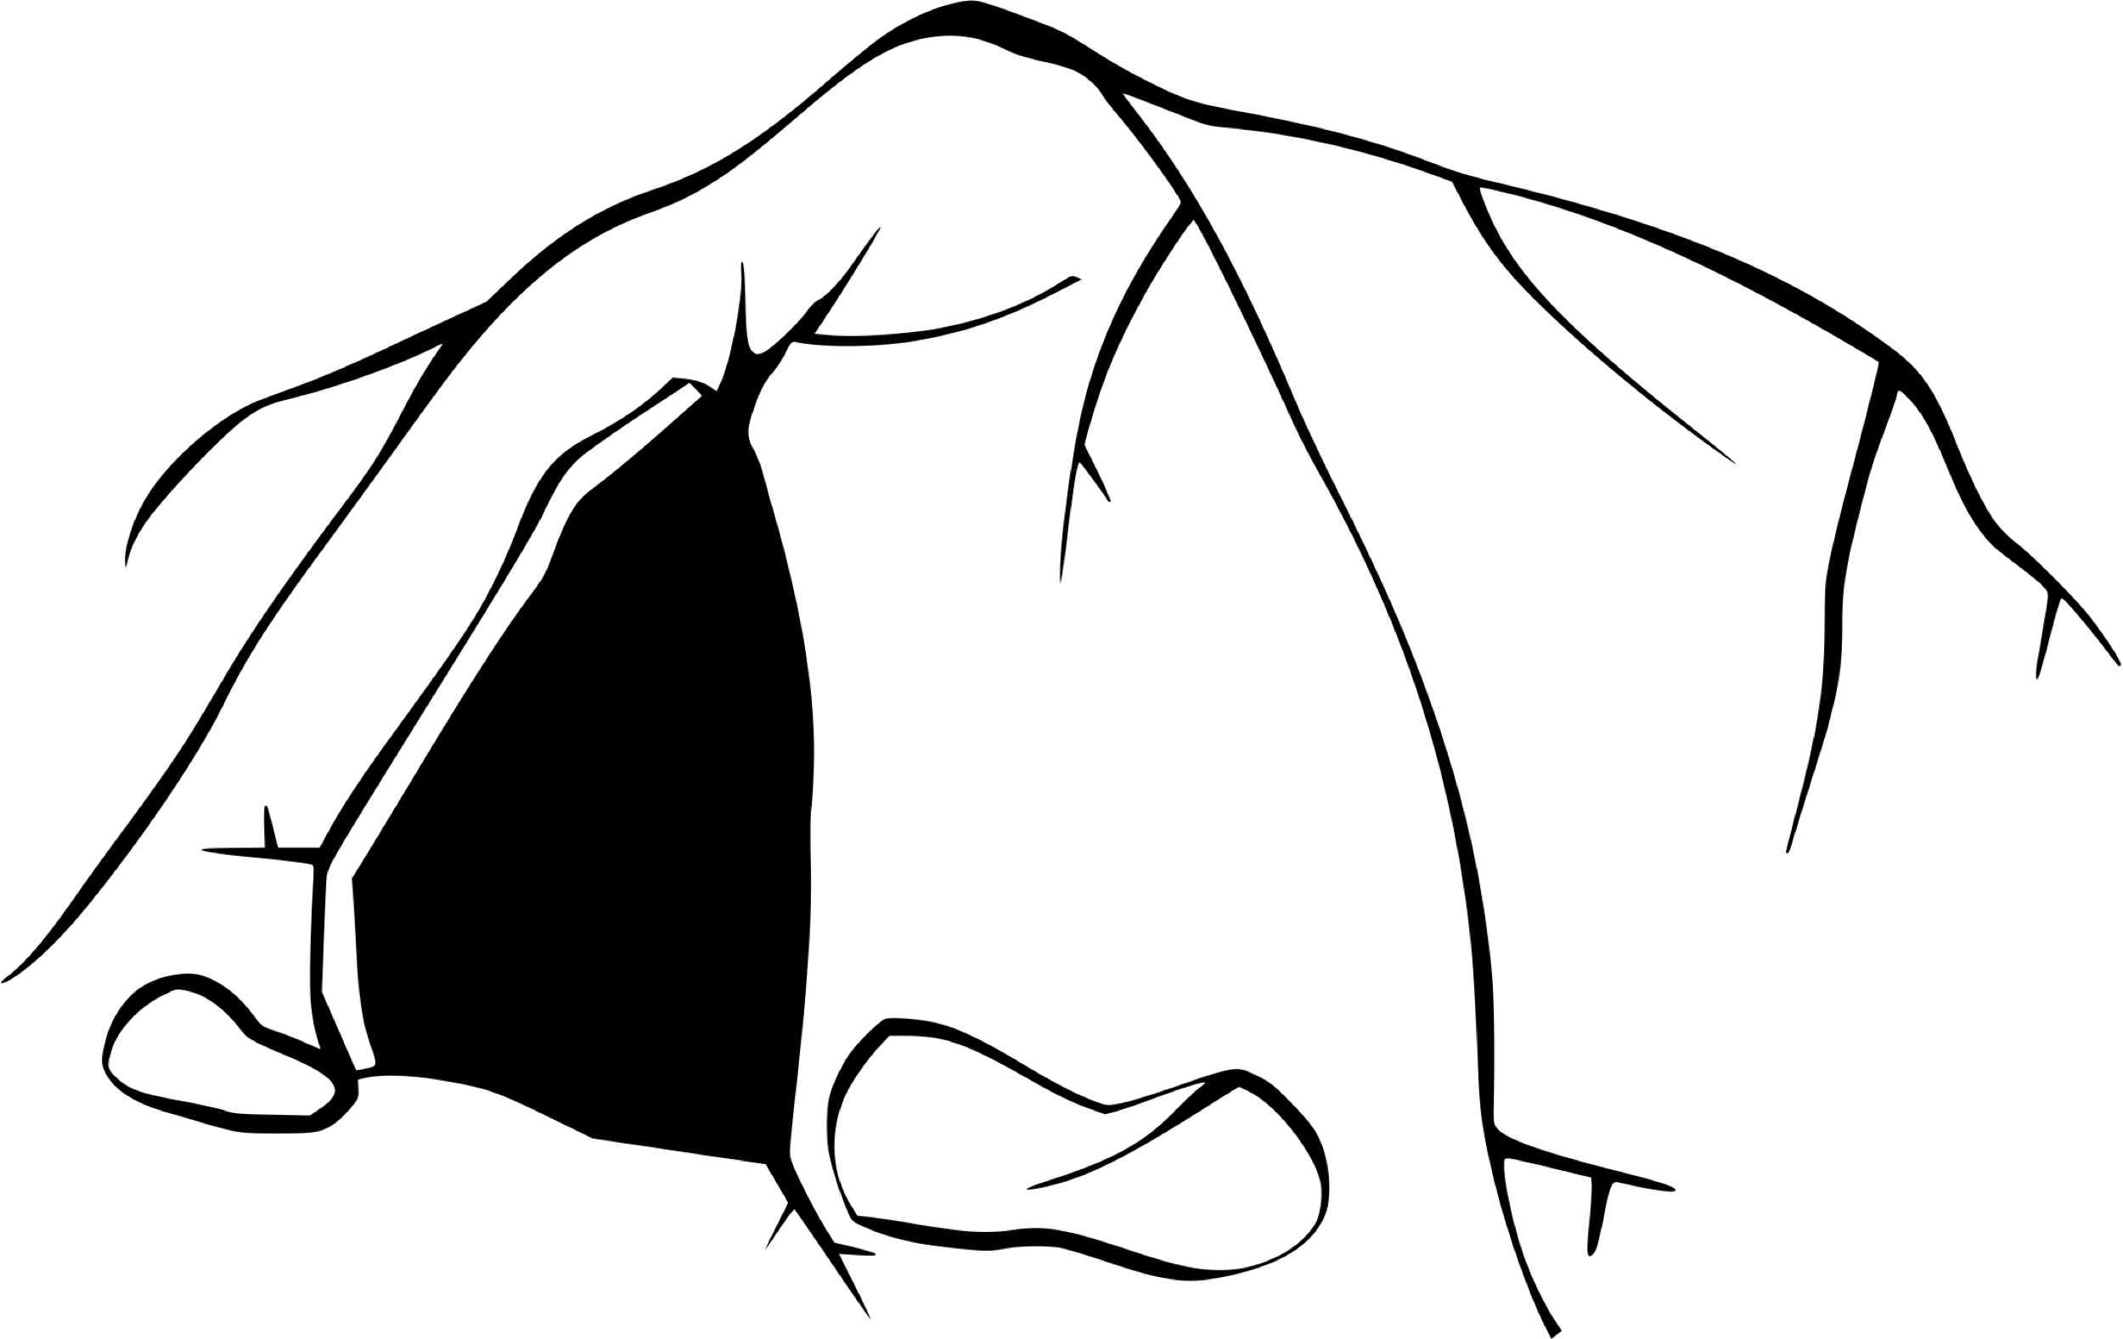

C_ _e of H _ _ _

What did the Prophet (SAW) do when he was in the cave?

____________________________________________

How old was the Prophet (SAW) when he became a prophet?

____________________________________________